**Contents**

**Chapter 1: Races**

Tantar

Zaan

Tyldin

Quinar

Alteran

Rhytos

**Chapter 2: Classes**

Mekromancer

Weaver

Protector

Stalker

Striker

**Chapter 3: Equipment**

Weapons

Armor

Mounts & Vehicles

Rings

Amulets

Shields

**Chapter 4: Combat**

Magic

Melee

Ranged

Poisons

Potions

**Chapter 5: Effects**

Poisons

Sanity

Potions

Injuries

Blood loss

Vampirism

Lycanthropy

**Chapter 1: Races**

**Choosing a Race:**

When choosing a race there are many things to consider:

* Age
* Ability Score Increases
* Speed
* Size
* Languages

Age determines the average lifespan of a race of creatures.

Ability score increases are the ability scores that are increased by choosing a race.

Speed is how much ground a creature can cover in one turn.

Size is the height span of a race of creatures.

Languages are the languages the race can speak, obviously.



**Tantar**

Typically, peaceful Ent people. They guard the trees along with Ent’s. Their bark tends to mimic the trees they guard. Are much smaller than your average Ent.

**Tantar Traits**

Ability Score Increase: Constitution +2

Age: Tantar typically tend to live to be around 150 to 250 years of age.

Alignment: Typically, a very good people.

Size: Tend to range from 6’5” to 7’5” and their weight ranges from 250 to 350 pounds. Your size is Medium.

Racial Ability: Once a day you can take a 10 on a Constitution saving throw/check.



**Zaan**

Smaller Fox-like people.

**Zaan Traits**

Ability Score Increase: Dexterity +2

Age: Tend to live between 60 to 70 years of age.

Alignment: Tend to be neutral.

Size Height ranges from 3’ to 4’ tall and weigh between 40 and 50 pounds. Your size is medium.

Racial Ability: Once a day you can take a 10 on a Dexterity saving throw/check.



**Tyldin**

Mainly women, tend to live near Tantars for protection. Forest dryad sort of people.

**Tyldin Traits**

Ability Score Increase: Intelligence +2

Age: Tend to range between 300 and 400 years

Alignment: Neutral

Size: Height ranges from 4’5” to 5’ 5”

Racial Ability: Once a day, you can take a 10 on an Intelligence saving throw/check.

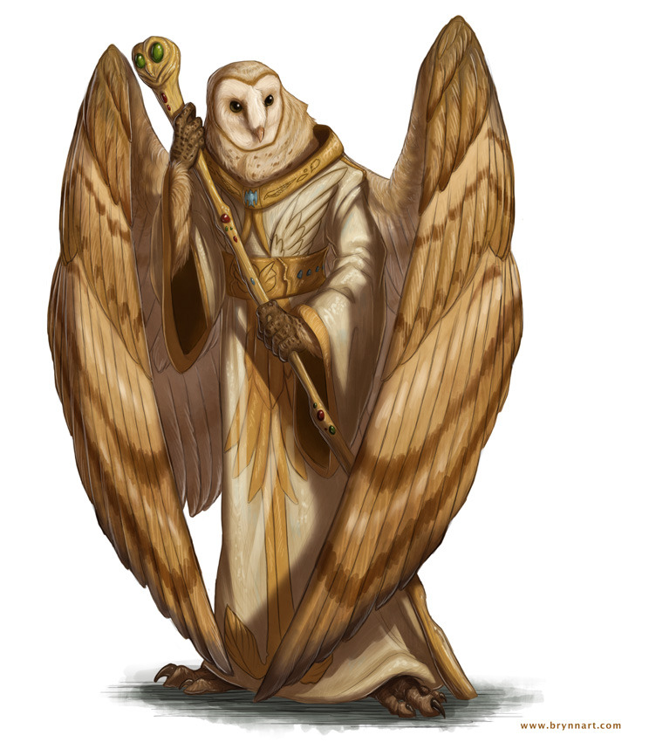

**Quinar**

Owl people

**Quinar Traits**

Ability Score Increase: Wisdom +2

Age: tend to live between 90 and 100 years

Alignment: Neutral

Size: Height ranging from 4’ to 5’

Racial Ability: Once a day you can take a 10 on a Wisdom saving throw/check.



**Alteran**

**Alteran Traits**

Ability Score Increase: Charisma +2

Age: tend to live between 90 and 100 years of age.

Alignment: Typically, good

Size: Height ranges from 4’ to 5’

Racial Ability: Once a day you can take a 10 on a Charisma saving throw/check.

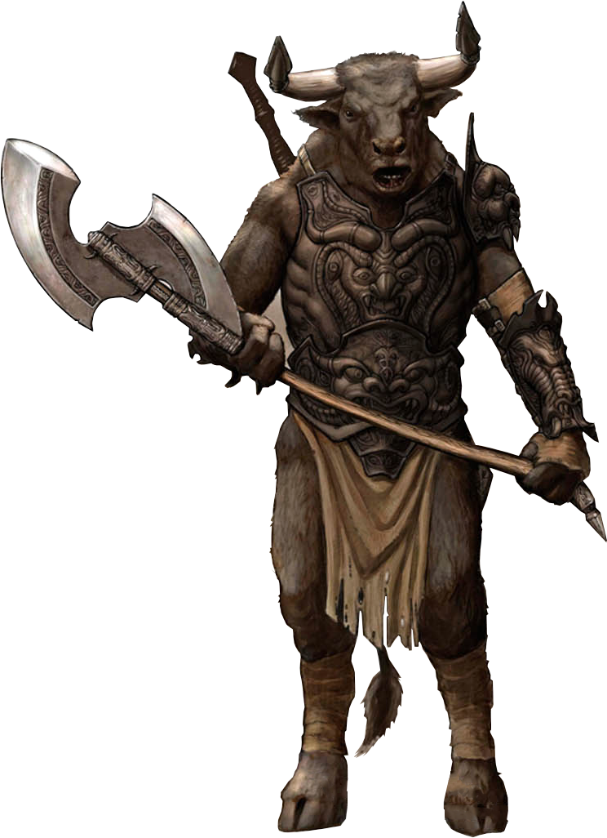

**Rhytos**

**Rhytos Traits**

Ability Score Increase: Strength +2

Age: Been known to live to 80

Alignment: Chaotic

Size: Height ranging from 5’ 10” to 6’ 8”

Racial Ability: Once a day you can take a 10 on a Strength saving throw/check.

**Chapter 2: Classes**

**Mekromancer:**

(Intelligence, tinkering self-explanatory based)

**Hit Points**

**Hit Dice:** 1d8 per Mekromancer level.

**Hit Points at 1st Level:** 8 + Constitution Modifier.

**Hit Points at Higher Levels:** 1d8(or 5) + your Constitution modifier per Mekromancer level after 1st.

**Proficiencies**

**Armor:** Light Armor

**Weapons**: Simple Weapons

**Tools**: Tinkerers Kit

**Saving Throws**: Intelligence

**Skills**: Tinkering, and choose one from Arcana, Perception, Medicine, Investigation, Insight, and History

**Equipment**

You start with the following equipment:

(a) Mace or Quaterstaff

(b) Light Hammer

(c) Tinkerers Tools

(d) Leather Armor

|  |  |  |  |
| --- | --- | --- | --- |
| Level | Proficiency Bonus | Features | Constructs  (if Constructor) |
| 1st | +2 | Intelligence +1, Scrap Gear | 2 |
| 2nd | +2 | Mek Archetype | 2 |
| 3rd | +2 | Mek Archetype Features | 2 |
| 4th | +2 | Ability Score Improvement | 2 |
| 5th | +3 |  | 2 |
| 6th | +3 | Mek Archetype Features | 3 |
| 7th | +3 |  | 3 |
| 8th | +3 | Ability Score Improvement | 3 |
| 9th | +4 |  | 3 |
| 10th | +4 | Mek Archetype Features | 3 |
| 11th | +4 |  | 4 |
| 12th | +4 | Ability Score Improvement | 4 |
| 13th | +5 |  | 4 |
| 14th | +5 | Mek Archetype Features | 4 |
| 15th | +5 |  | 4 |
| 16th | +5 | Ability Score Improvement | 5 |
| 17th | +6 | Mek Archetype Features | 5 |
| 18th | +6 |  | 5 |
| 19th | +6 | Ability Score Improvement | 5 |
| 20th | +6 | Mek Archetype Features | 5 |

**SCRAP GEAR:**

You can deconstruct gear for scrap (assuming the gear is made of a sort of metal).

------------------

**Archetypes:**

**Scrap-Lord:**

You specialize in improving or creating weapons and armor to aid you in battle. You gain weakness to lightning damage.

**SCRAP ARMOR:**

**1st Stage:** You can spend an action putting scrap on top of your armor (and likewise for taking it off) the scrap adds +1 to your AC but reduces your speed by 1ft. You lose one scrap.

**2nd Stage:** You can spend an action putting scrap on top of your armor more efficiently (and likewise for taking it off) the scrap adds +2 to your AC but reduces your speed by 2 ft. You lose one scrap.

**3rd Stage:** You can spend an action putting scrap on top of your armor even more efficiently (and likewise for taking it off) the scrap adds +2 to your AC but reduces your speed by 2 ft. You lose one scrap.

**4th Stage:** You can spend an action putting scrap on top of your armor even more efficiently (and likewise for taking it off) the scrap adds +3 to your AC but reduces your speed by 3 ft. You lose one scrap.

-----------------

**Scrap Weapon:**

**1st Stage:** You can spend an action putting scrap on your weapon, the weapon now does an additional 1d4 slashing damage. the scrap reduces your speed by 3 ft. You lose one scrap.

**2nd Stage:** You can spend an action putting scrap on your weapon, the weapon now does an additional 1d6 slashing damage. the scrap reduces your speed by 2 ft. You lose one scrap.

**3rd Stage:** You can spend an action putting scrap on your weapon, the weapon now does an additional 1d8 slashing damage. the scrap reduces your speed by 2 ft. You lose one scrap.

**4th Stage:** You can spend an action putting scrap on your weapon, the weapon now does an additional 1d10 slashing damage. the scrap reduces your speed by 1 ft. You lose one scrap.

-----------------

**Scrap Shield:**

**1st Stage:** You can spend an action putting scrap on your shield, the shield now blocks 1d4 physical damage. the scrap reduces your speed by 3 ft. You lose one scrap.

**2nd Stage:** You can spend an action putting scrap on your shield, the shield now blocks 1d6 physical damage. the scrap reduces your speed by 2 ft. You lose one scrap.

**3rd Stage:** You can spend an action putting scrap on your shield, the shield now blocks 1d8 physical damage. the scrap reduces your speed by 2 ft. You lose one scrap.

**4th Stage:** You can spend an action putting scrap on your shield, the shield now blocks 1d10 physical damage. the scrap reduces your speed by 1 ft. You lose one scrap.

-----------------

**Scrap-On:**

You must clap twice and say “scrap-on” to the tune of Clap on, then you can do any of the listed abilities (Scrap Armor, Scrap Shield, Scrap Weapon) for an allied creature. You lose one scrap.

**Scrap-Off:**

You must clap twice and say “scrap-off” to the tune of Clap on, then you can remove any scrap from a creature within 5 ft of you. You gain X scrap where x is the number of scrap on that creature.

-----------------

**Constructor:**

You specialize in constructing various machines to aid you.

**Animal Mimekry:**

You can spend an action to build a mek of a creature less than or equal to 2/3 your Constructor level in Combat Rating. (the stats of the mek are the same as the creature it mimics it does not gain any magical abilities unless enchanted (must roll d20 for success chance))

-----------------

**Mek Suit:**

You can spend a day (or 6 hours with 3 people helping) building a mek suit. While wearing the Mek suit you gain +4 AC (max 18)

-----------------

**Weapon Construction:**

**1st Stage:** You can spend 3d4 hours building a mechanical weapon. The weapon can be of any type and gives +1 to attack. You lose 1 scrap if it is a light weapon, 2 if it is neither heavy or light weapon, and 3 if it is a heavy weapon.

**2nd Stage:** You can spend 2d4 hours building a mechanical weapon. The weapon can be of any type and gives +1 to attack. You lose 1 scrap if it is a light weapon, 2 if it is neither heavy or light weapon, and 3 if it is a heavy weapon.

**3rd Stage:** You can spend 2d4 hours building a mechanical weapon. The weapon can be of any type and gives +2 to attack. You lose 1 scrap if it is a light weapon, 2 if it is neither heavy or light weapon, and 3 if it is a heavy weapon.

**4th Stage:** You can spend 1d4 hours building a mechanical weapon. The weapon can be of any type and gives +3 to attack. You lose 1 scrap if it is a light weapon, 2 if it is neither heavy or light weapon, and 3 if it is a heavy weapon.

-----------------

**Armor Construction:**

**1st Stage:** You can spend 3d4 hours building a piece of mechanical armor. The armor can be of any type and gives +1 to AC. You lose 1 scrap if it is light armor, 2 if it is medium armor, and 3 if it is a heavy armor. The armor gives disadvantage to stealth checks.

**2nd Stage:** You can spend 2d4 hours building a piece of mechanical armor. The armor can be of any type and gives +1 to AC. You lose 1 scrap if it is light armor, 2 if it is medium armor, and 3 if it is a heavy armor. The armor gives disadvantage to stealth checks.

**3rd Stage:** You can spend 2d4 hours building a piece of mechanical armor. The armor can be of any type and gives +2 to AC. You lose 1 scrap if it is light armor, 2 if it is medium armor, and 3 if it is a heavy armor. The armor gives disadvantage to stealth checks.

**4th Stage:** You can spend 2d4 hours building a piece of mechanical armor. The armor can be of any type and gives +2 to AC. You lose 1 scrap if it is light armor, 2 if it is medium armor, and 3 if it is a heavy armor. The armor gives disadvantage to stealth checks.

-----------------

**ALL MECHANICAL EQUIPMENT HAS A HP VALUE BASED ON HOW WELL IT WAS MADE (USES TINKERING CHECK)**

**ALL MECHANICAL EQUIPMENT SUFFERS HP DAMAGE WHEN IT IS HIT AS WELL AS OVER TIME.**

**MECHANICAL EQUIPMENT LOSES 1 HP EVERY HOUR.**

**Weaver:**

**Protector:**

**Stalker:**

**Striker:**